Docker Commands, Docker Compose Codes, and Frameworks Used

1. What is Docker?
Frameworks/Technologies Used
- Docker Engine
- Linux Containers (LXC)
- Containerd
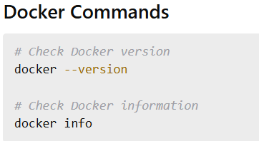

2. What is Containerization?
Frameworks/Technologies Used
- Docker
- Kubernetes
- Podman
- Containerd
Docker Commands
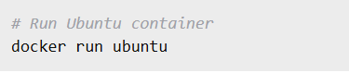

3. Difference Between Docker and Virtual Machines
Frameworks Used
- VMware
- VirtualBox
- Hyper-V
- Docker
Docker Commands
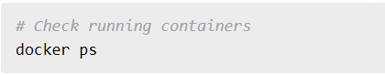

4. What is Docker Image?
Frameworks Used
- Docker Hub
- OCI Images
Docker Commands
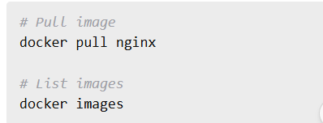

5. What is Docker Container?
Docker Commands
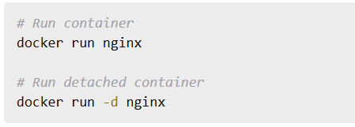

6. Docker Architecture
Components
- Docker Client
- Docker Daemon
- Docker Registry
Docker Commands


7. Docker Lifecycle Commands
Docker Commands
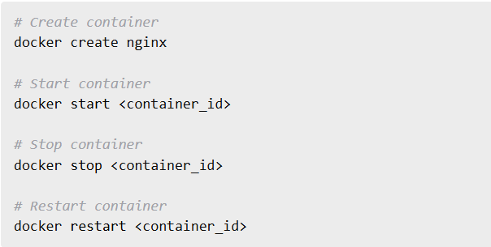

8. Dockerfile Basics
Frameworks Used
- Python Flask
- Node.js
- Java Spring Boot

Dockerfile Example
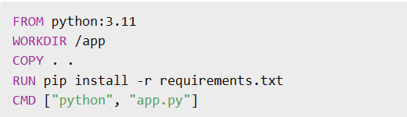

9. CMD vs ENTRYPOINT
Dockerfile Example
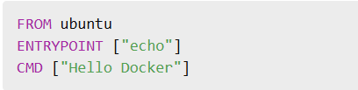

10. COPY vs ADD
Dockerfile Example


11. Building Docker Images
Docker Commands
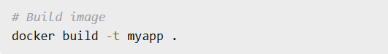

12. Tagging Docker Images
Docker Commands

13. Pushing Images to Docker Hub
Docker Commands
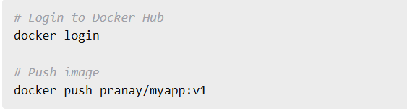

14. Docker Volumes
Frameworks Used
- MySQL
- PostgreSQL
- MongoDB
Docker Commands
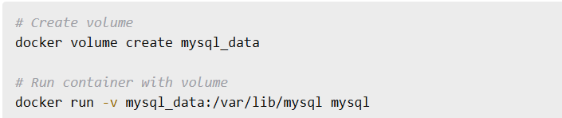

15. Bind Mounts vs Volumes
Docker Commands
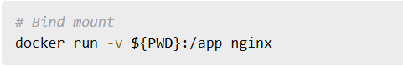

16. Docker Networking
Network Types
- Bridge
- Host
- Overlay
- None
Docker Commands
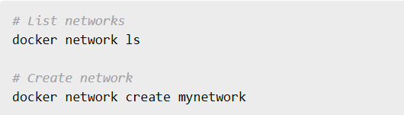

17. Port Mapping
Docker Commands
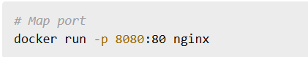

18. Docker Logs
Docker Commands
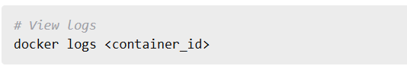

19. Docker Exec
Docker Commands
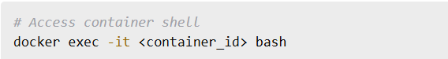

20. Docker Inspect
Docker Commands


21. Docker Compose Introduction
Frameworks Used
- Nginx
- Node.js
- MySQL
- Redis
docker-compose.yml
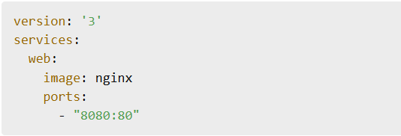

22. Multi-Container Application Using Docker Compose
Frameworks Used
- React
- Node.js
- MongoDB
docker-compose.yml
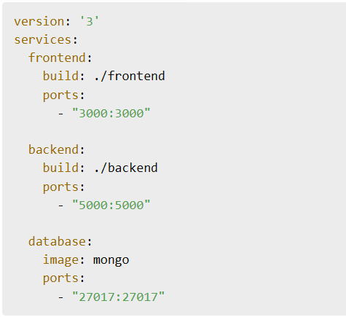

23. MySQL with Docker Compose
Frameworks Used
- MySQL
- phpMyAdmin
docker-compose.yml
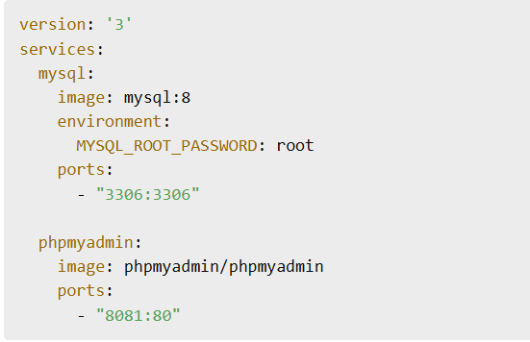
24. Node.js App Dockerfile
Framework Used
- Node.js
- Express.js
Dockerfile
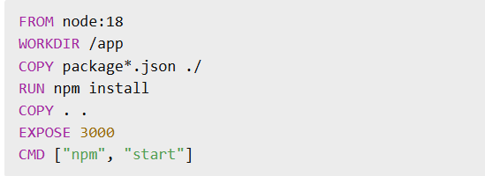

25. Flask App Dockerfile
Framework Used
- Python Flask
Dockerfile
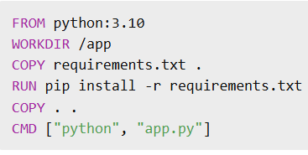

27. Multi-Stage Docker Build
Dockerfile
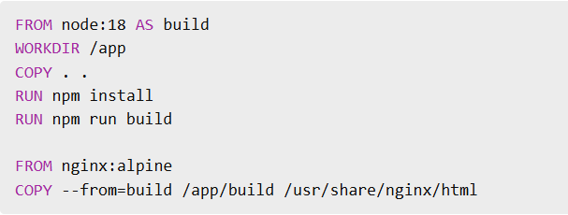

28. Docker Compose with Redis
Frameworks Used
- Redis
- Node.js
docker-compose.yml
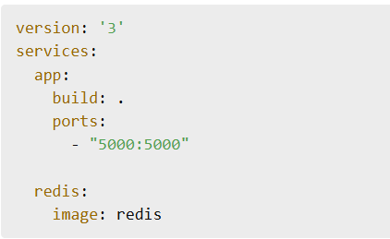

29. Docker Environment Variables
Docker Commands

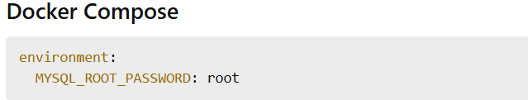

30. Docker Secrets
Frameworks Used
- Docker Swarm
Docker Commands

31. Docker Swarm Basics
Docker Commands
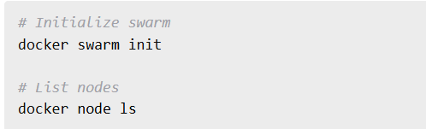

32. Deploy Service in Docker Swarm
Docker Commands

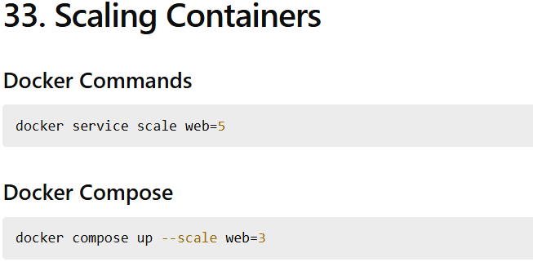

35. Docker Restart Policies
Docker Commands

36. Resource Limits in Docker
Docker Commands

37. Docker Compose Networks
docker-compose.yml
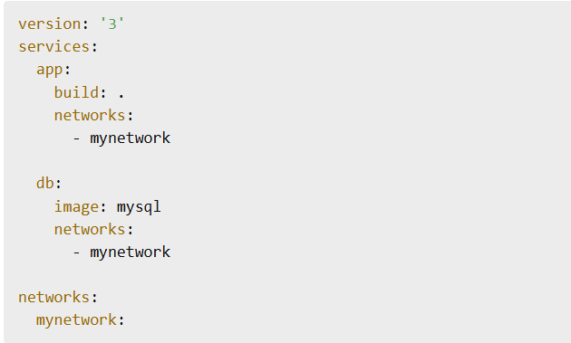
38. Docker Compose Volumes
docker-compose.yml
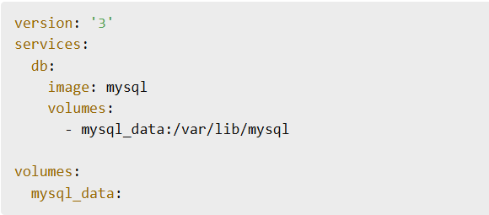

39. Docker Compose Environment File
.env File
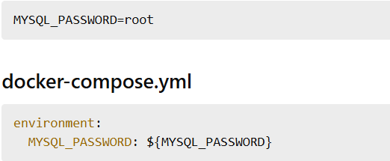

40. Docker Compose Commands
Docker Compose Commands
